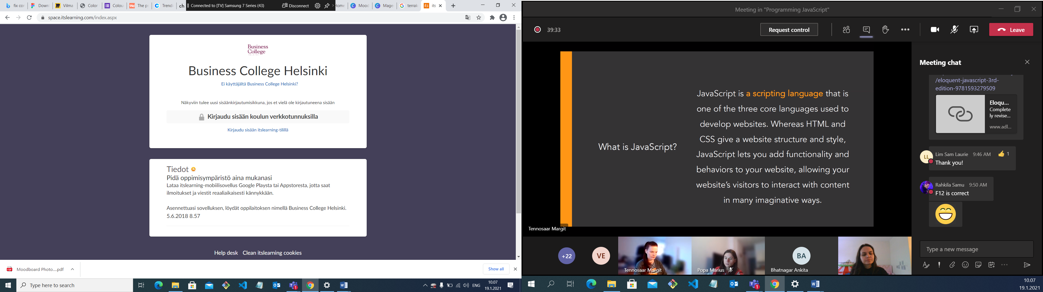

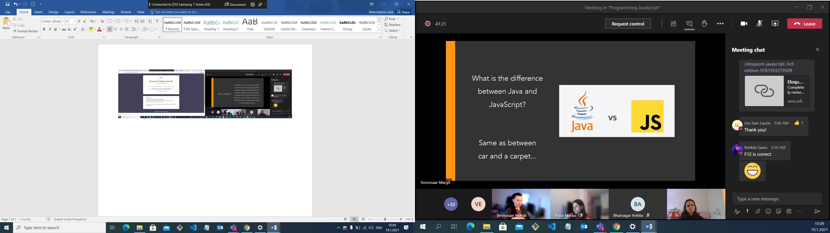

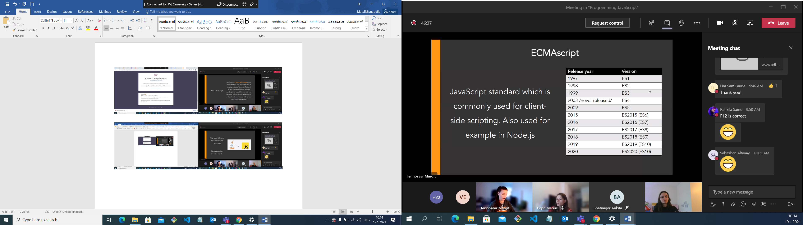

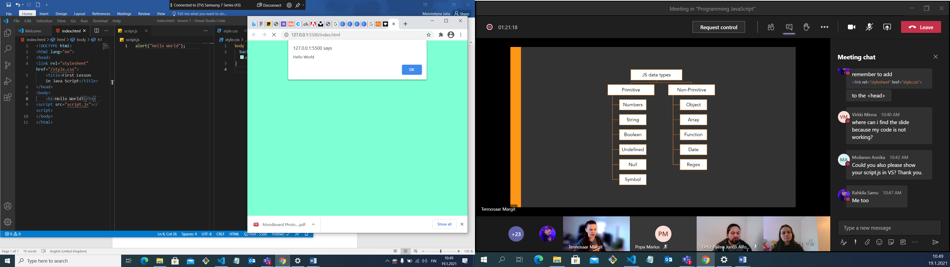

Boolean – true/false

Undefined – we don’t know what it is, no value

Null – empty

Symbol – object property

Nan – not a number

5\*\*2 – stepen

5%2 -?

Let x=10;

X++;

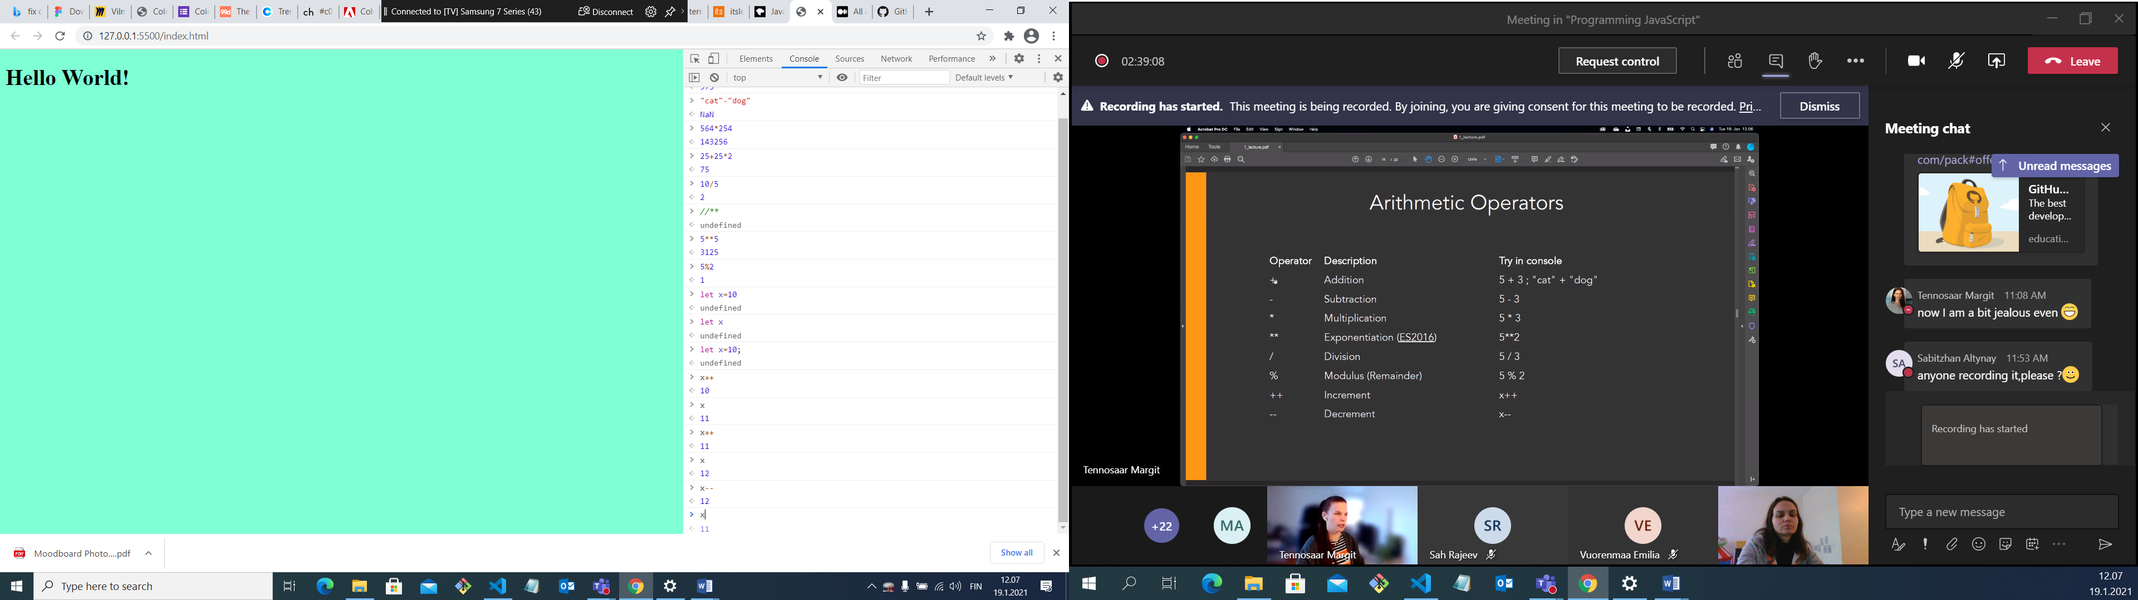

Let margit=”margrit”

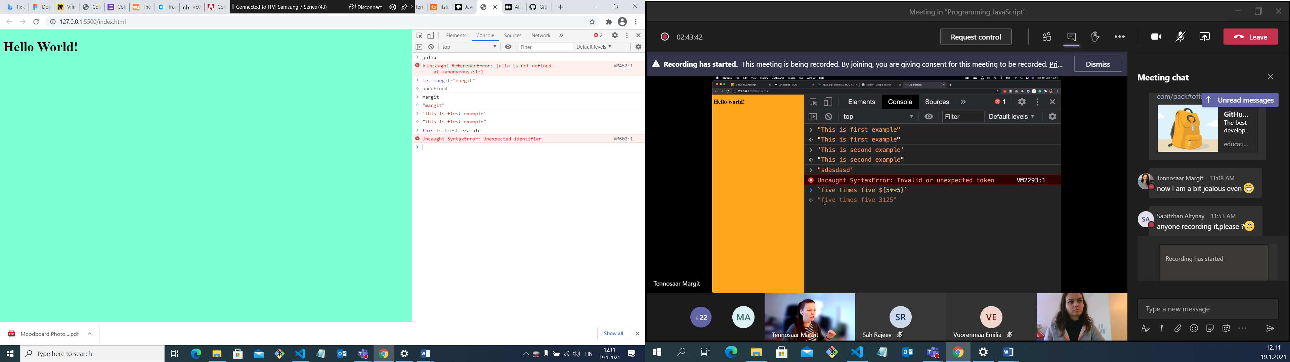

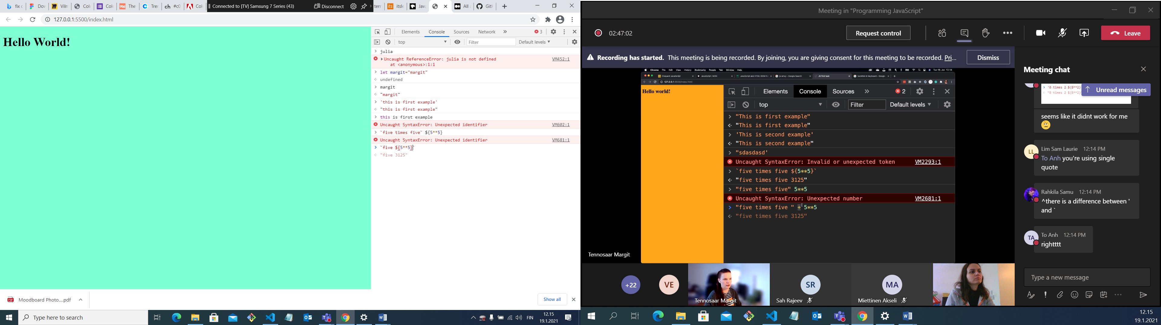

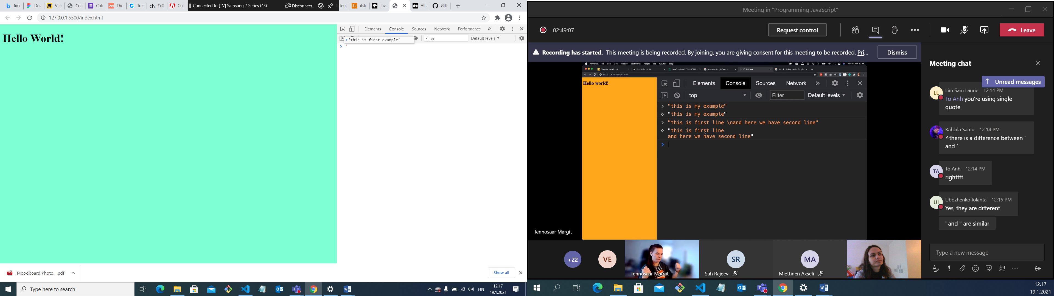

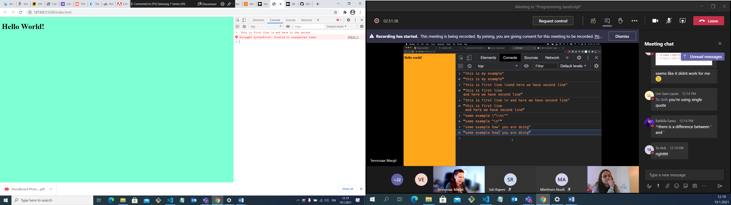

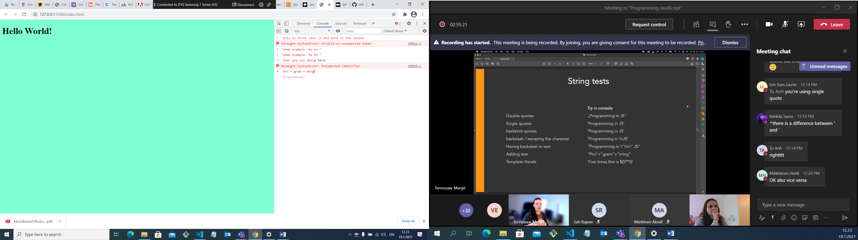

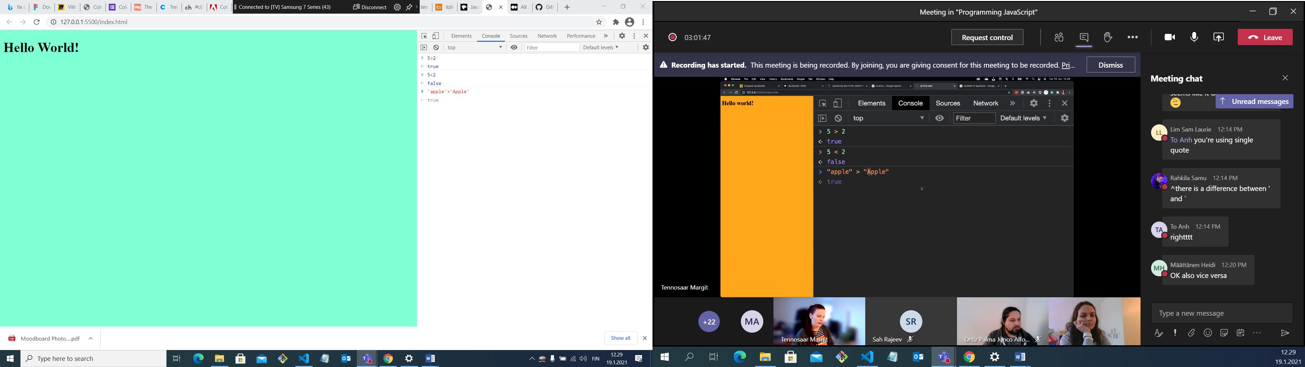

Case sensitive language, manage the capital letters

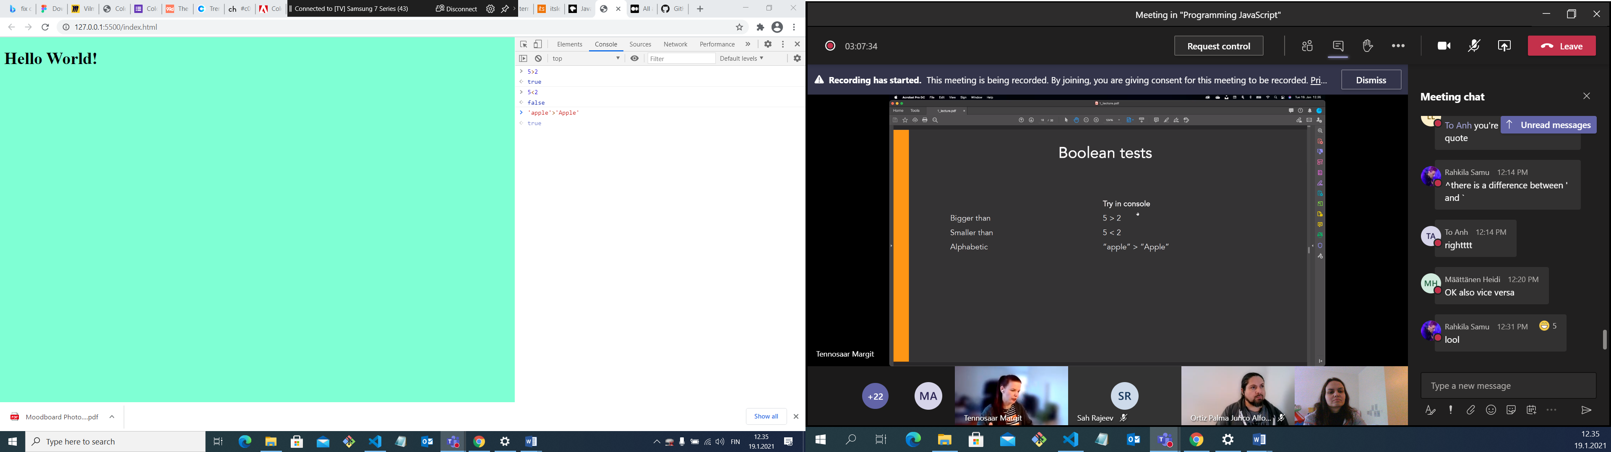

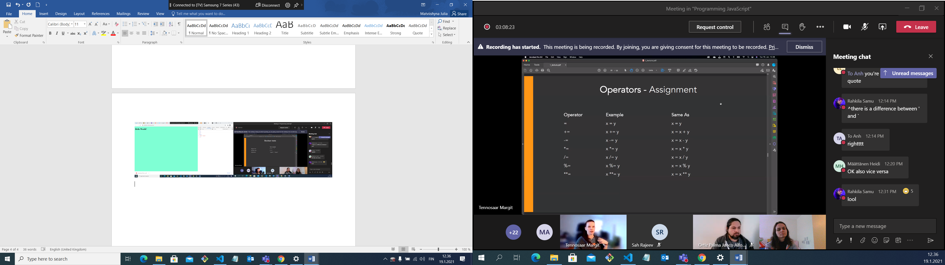

+= new x will be equal …

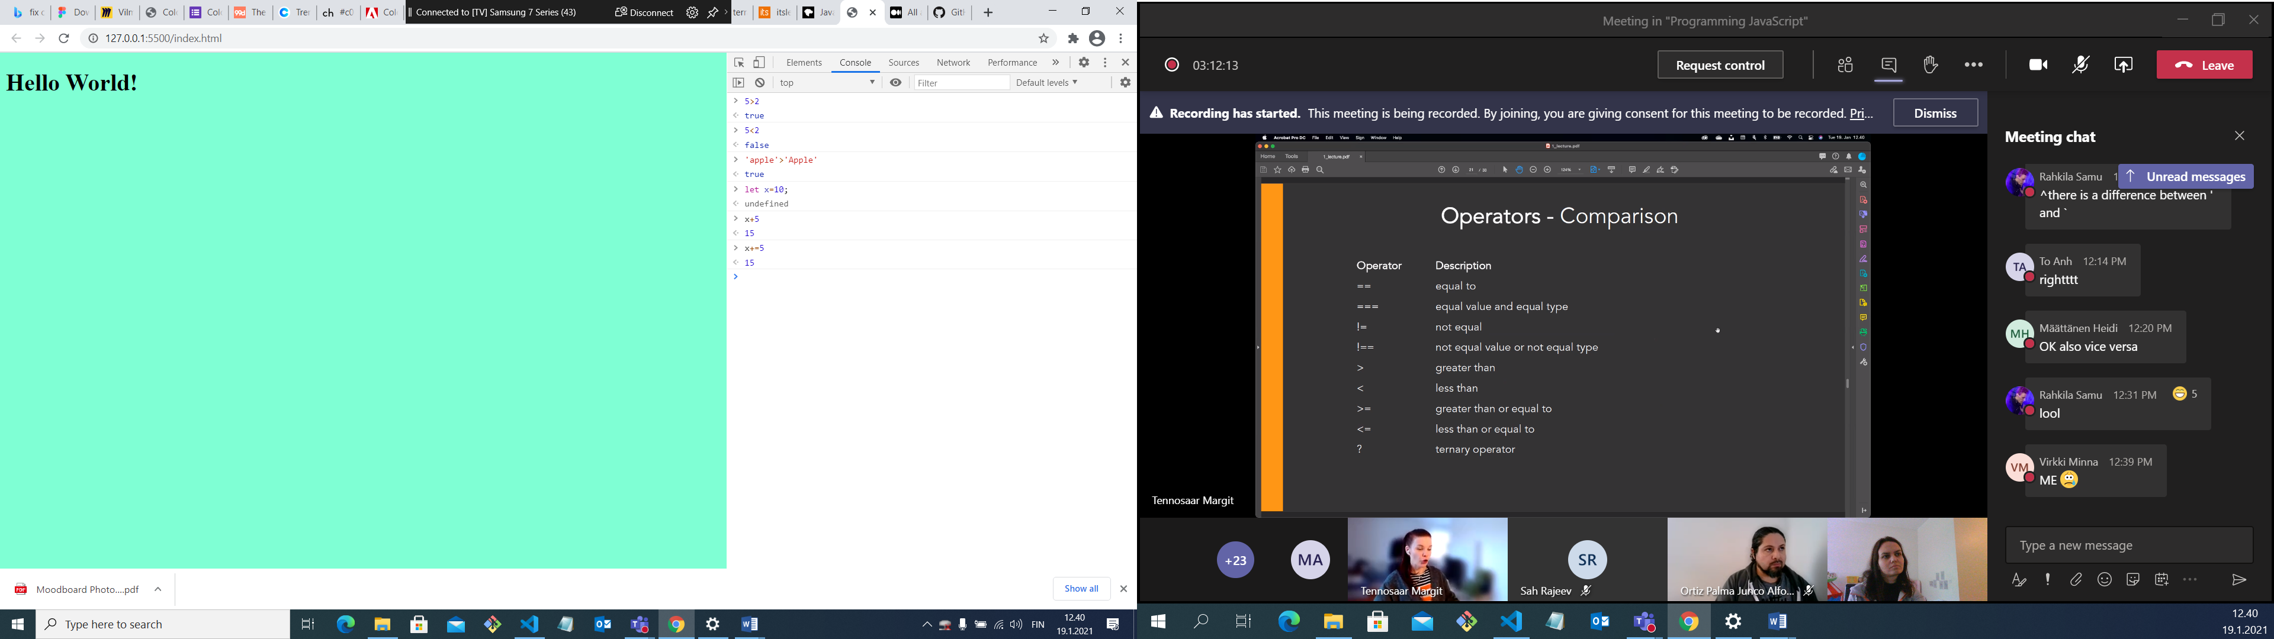

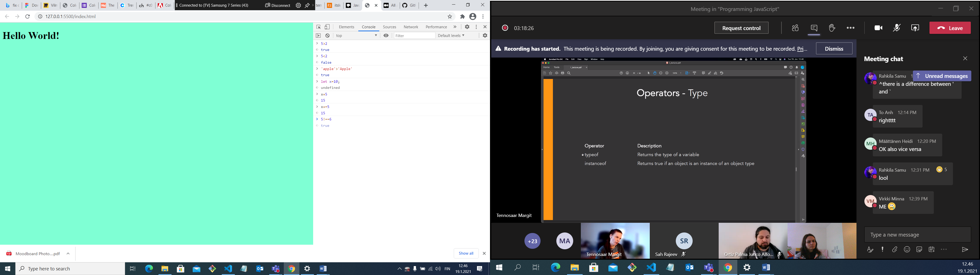

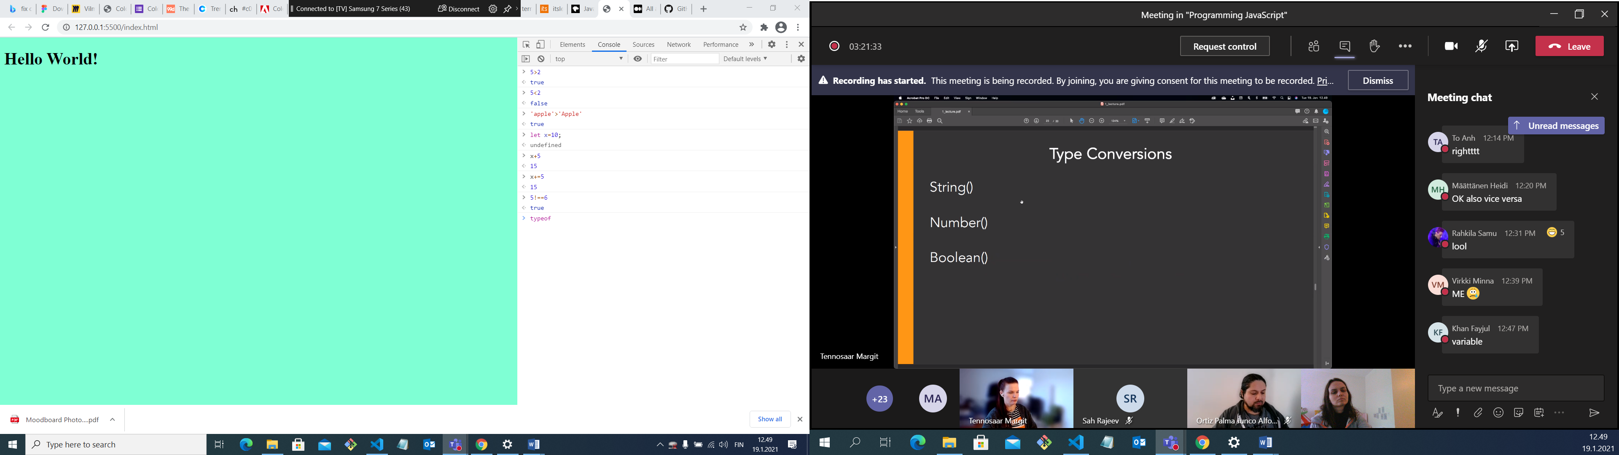

Convert number to string and vice versa

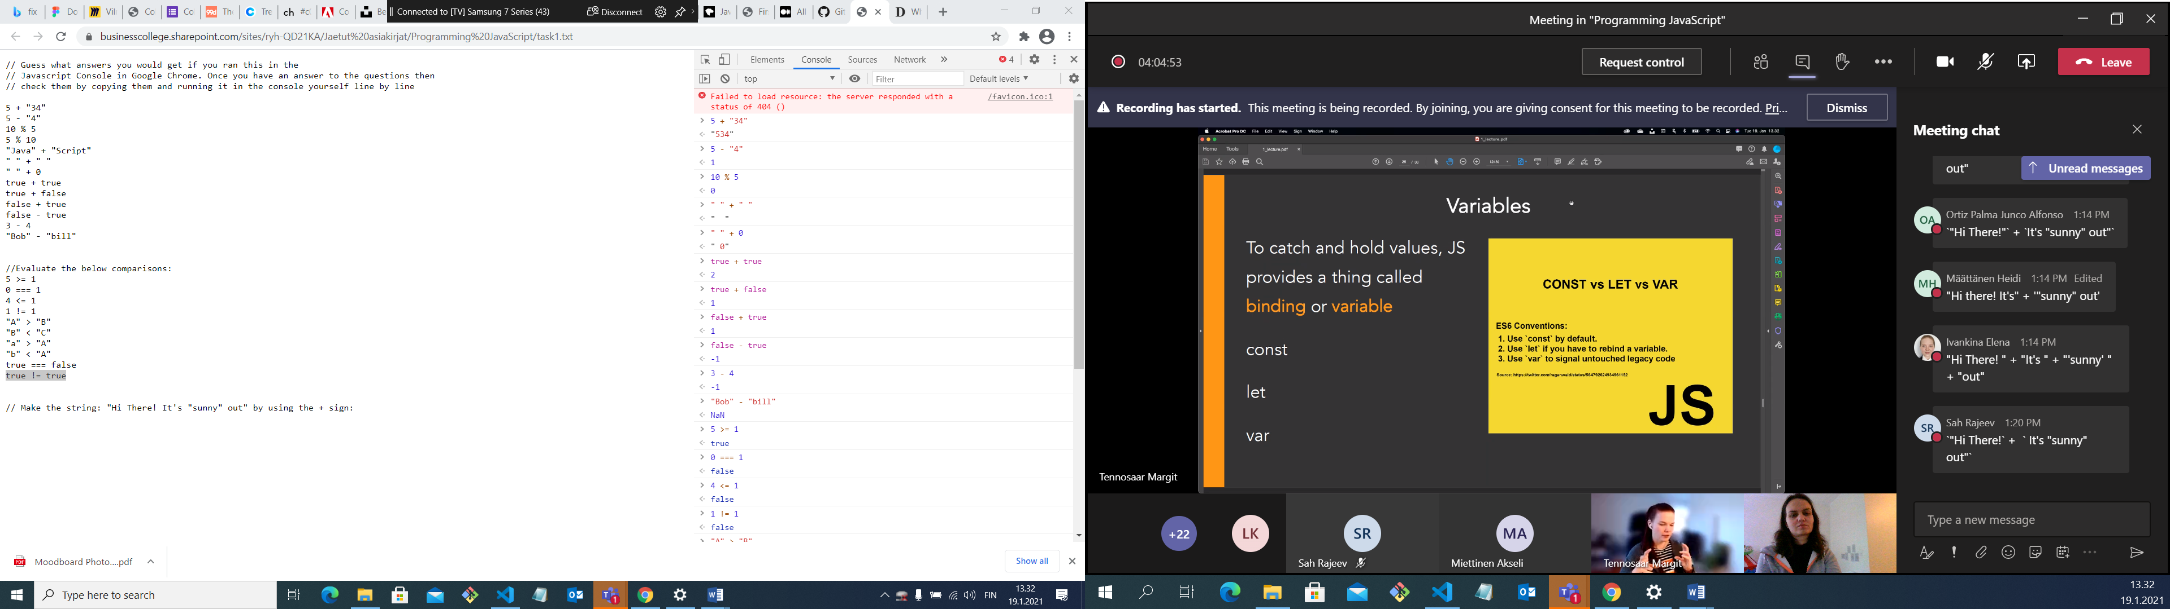

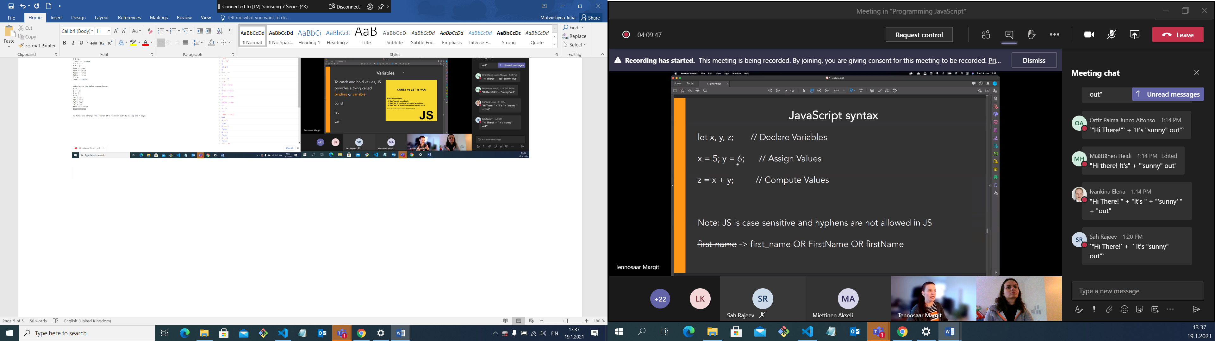

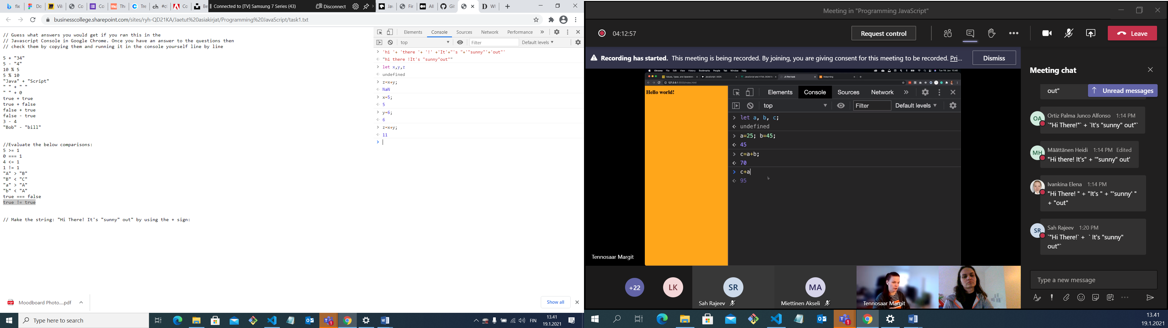

You can’t use this as variabbles

